When trying to read one of the files, by means of “fread”, we encounter the following error message:

> sample <- fread(paste0("unzip -p ","2017-03-29.zip"), sep = ";")
Error in fread(paste0("unzip -p ", "2017-03-29.zip"), sep = ";") :
Expected sep (';') but new line, EOF (or other non printing character) ends field 0 when detecting types from point 10: RT NEG 2017-03-29 2017-03-29 000953876
In addition: Warning message:
In fread(paste0("unzip -p ", "2017-03-29.zip"), sep = ";") :
Starting data input on line 2 and discarding line 1 because it has too few or too many items to be column names or data: RH NEG 2017-03-29 2017-03-29 000953876

This suggests that the first and last line of our dataset are just header and footer file info, therefore they’re not part of the data. Our first attempt to overcome this issue, was to specify the optional parameters “skip” and “nrow” when calling the function fread. By setting “skip=1” we can easily skip the 1st line and with nrow we should tell the function to read n-1 line after skipping the 1st. The problem is that we should know the number of lines before reading the file. This could be done without too much effort using the linux teminal, however
For this reason, we decided to

In order to clean the data from these two lines, we can type the command “zgrep -vE "RH NEG|RT NEG" 2017-03-29.zip > result” into the linux terminal. In order to automate this operation we can call the command from the R console by means of the function “system()”. Here we report the final lines used to read the files:

system("cd ~/Desktop/BigData/data")
system(command = "zgrep -vE 'RH NEG|RT NEG' 2017-03-29.zip > temp")
sample <- fread("temp", sep = ";")
system("rm -f temp")

Cleaning/Formatting data + challenges

The raw dataset contains 2 different columns for date and time, each of class “character”. As we learnt in class, this is not a good way of handling time data, therefore we would like to collapse this two column into one and convert it to an POSIXct object through the following command line:

sample[,Datetime] <- as.POSIXct(paste(sample$Date, sample$Time), format = "%Y-%m-%d %H:%M:%S", tz="UTC")

However, after converting the time into POSIXct, we notice that there are some rows with the same ticker and the same exact date and time. This is because the original time was taking into account event fraction of seconds, whereas in the POSIXct object we stop at “second” resolution (we won’t need a better time resolution since it varies across tickers from fraction of seconds to few observations per day → because is trading data).
At this stage, we would like to further inspect our data to better understand what kind of time resolution we can use, but before doing so, we are going to fix the problem with multiple identical time we mention above.
What we would like to do is to compute an average price for the multiple lines with the same time (and of course same ticker), then remove all duplicate rows. Finally iterate this operation for all tickers. Luckily, we can avoid using for loops thanks to the data.table library, which we are using to handling the data.

sample[, Price:=mean(Price), by="Symbol,Datetime"]
sample <- sample[!duplicated(sample, by = c("Symbol","Datetime")),]
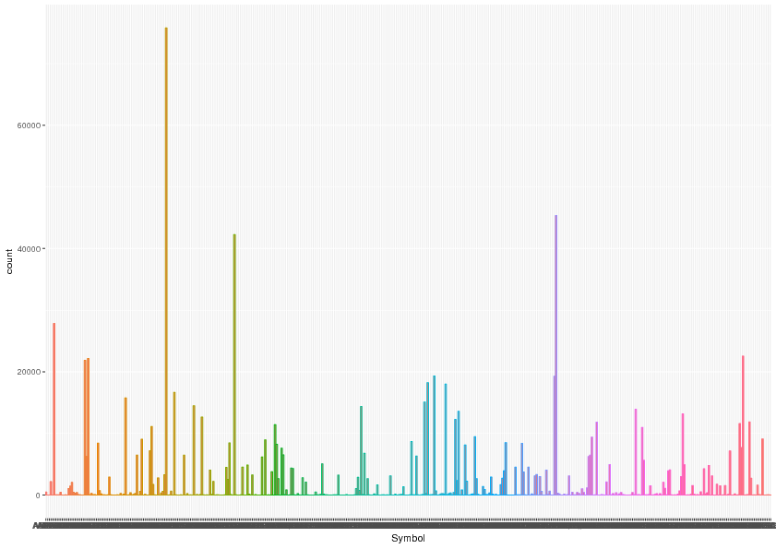

Parallel speed-up:

Parallel, 12 files:
user system elapsed
0.412 0.028 35.077

No Parallel, 12 files:
user system elapsed
49.676 1.208 50.904

100 files with 6 workers: (with 8 workers it was around 200 s but the usage of ram was higher)
user system elapsed
0.304 0.024 226.246

PARALLEL.R

All files with 6 workers:
user system elapsed
0.512 0.112 1084.710

CLEANING: (about 40min)

setwd("/home/antonio/Desktop/BigData/codes")
> system.time(source("cleaning.R"))
user system elapsed
0.336 0.032 2463.559

AGGREGATING (about 15 min)

> setwd("/home/antonio/Desktop/BigData/codes")
> system.time(source("aggregate_cleaned_data.R"))
user system elapsed
0.576 0.028 964.168

